Product category: SWITCHGEARS

COMPANY : AUTONICS

1. Model name: VOLTMETER

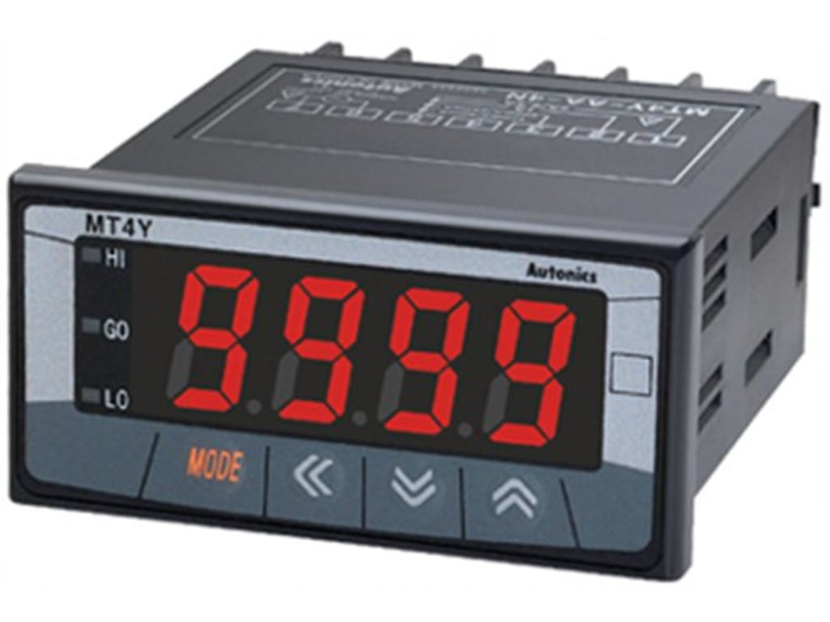

1. **MODEL NAME : AMPERE METER**

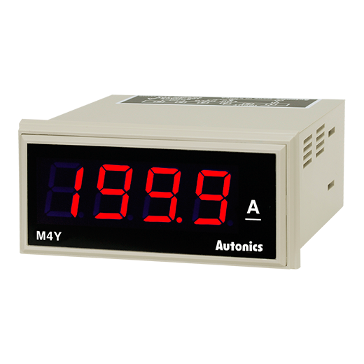

1. MODEL NAME: RPM METER

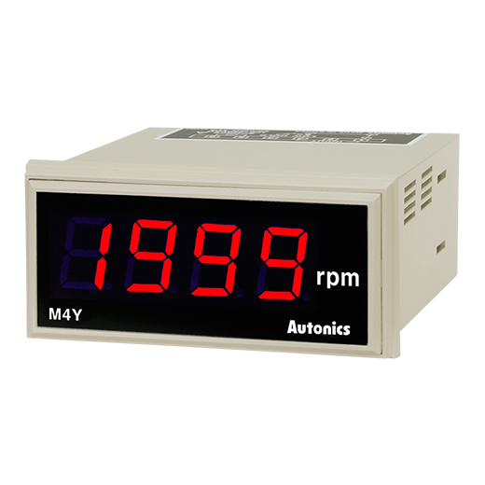

1. MODEL NAME: COUNTER METER

[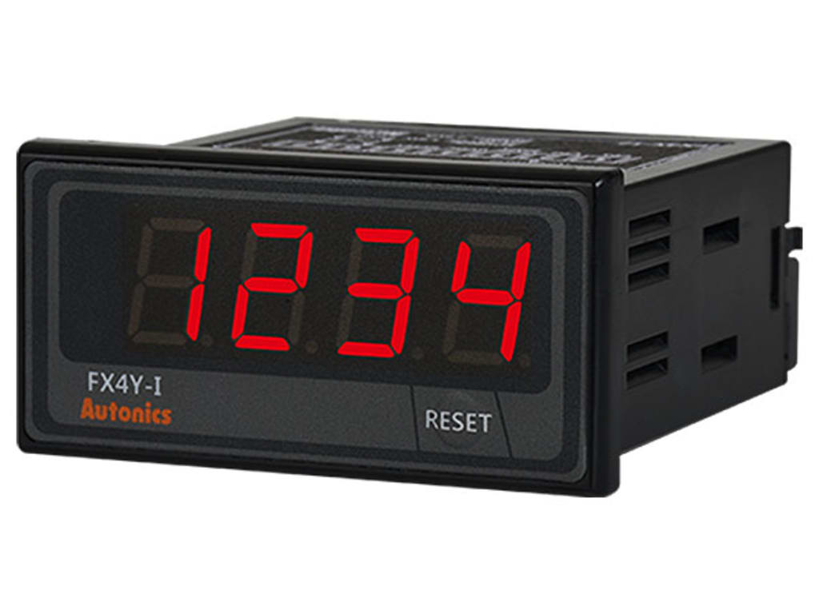](https://www.deltaelectronicsindia.com/industrial-automation/touch-panel-hmi-human-machine-interfaces/tp70p/" \o "TP70P)

1. MODEL NAME: TIMERS

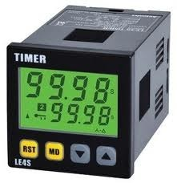

1. MODEL NAME: PID CONTROLLER

